**Lesson 3 Test the onboard active buzzer**

**Table**

1 Introduction of the buzzer 1

2 Principle 1

3 Components & Parts 2

4 Circuit 3

5 Upload code and test 3

6 Any questions and suggestions are welcome 9

# 1 Introduction of the buzzer

Buzzer is a kind of voice device that converts audio model into sound signal. It is masterly used to prompt or alarm. According to different design and application, it can produce music sound, flute sound, buzzer, alarm sound, electric bell and other different sounds.

There are two types of piezoelectric buzzers that are commonly used in electronics projects – active buzzers and passive buzzers. Active buzzers are called active because they only need a DC voltage to produce sound. Passive buzzers need an AC voltage to produce sound.

# 2 Principle

Active Buzzer doesn’t need a varying voltage, you just give it constant voltage and it has an internal chopper (oscillator) circuit that turns the constant voltage to a square wave and feeds that to the piezo disc to generate a fixed-frequency tone.

**Schematic:**

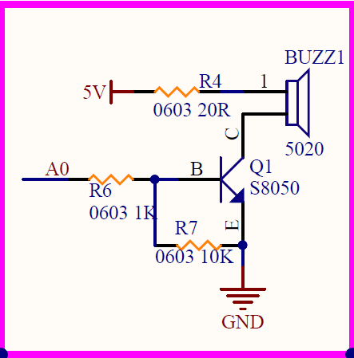

This buzzer signal occupies the A0 pin of Atmega328p on the driver board.

# 3 Components & Parts

|  |  |  |
| --- | --- | --- |
| Components | Quantity | Picture |
| USB cable | 1 |  |
| Robotic Arm Driver Board | 1 | Robotic Arm Driver Hat |

# 4 Circuit

Referring to the figure below, connect the driver board to the computer with a USB cable. Since the power of the onboard buzzer is very small, it can be powered by a USB cable and does not require an external power supply.

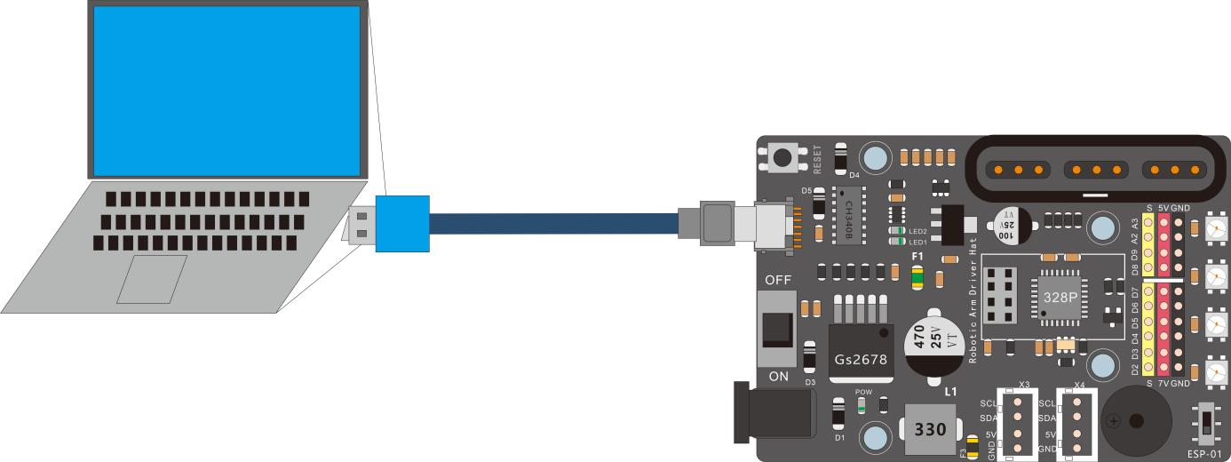

# 5 Upload code and test

**buzzer**

The code used in this lesson is placed in this folder: E:\CKK0017-main\Tutorial\sketches

5.1 Double-click the Arduino IDE shortcut on the desktop to open it

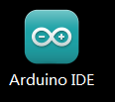

Buzzer_test

5.2 On the Arduino IDE interface, click "File" --- "open"

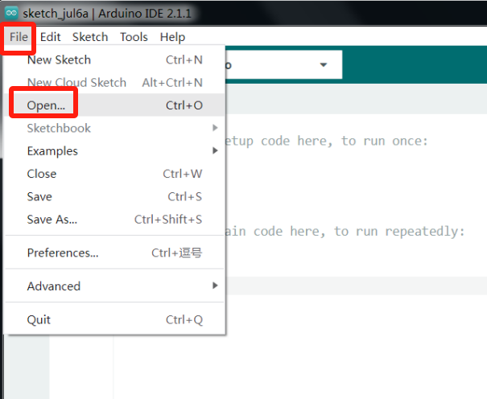

5.3 Select the code in the folder named 1_1_buzzer_test:

E:\CKK0017-main\Tutorial\sketches\1_1_buzzer_test

After selecting the code, click "open", the interface is as Follows

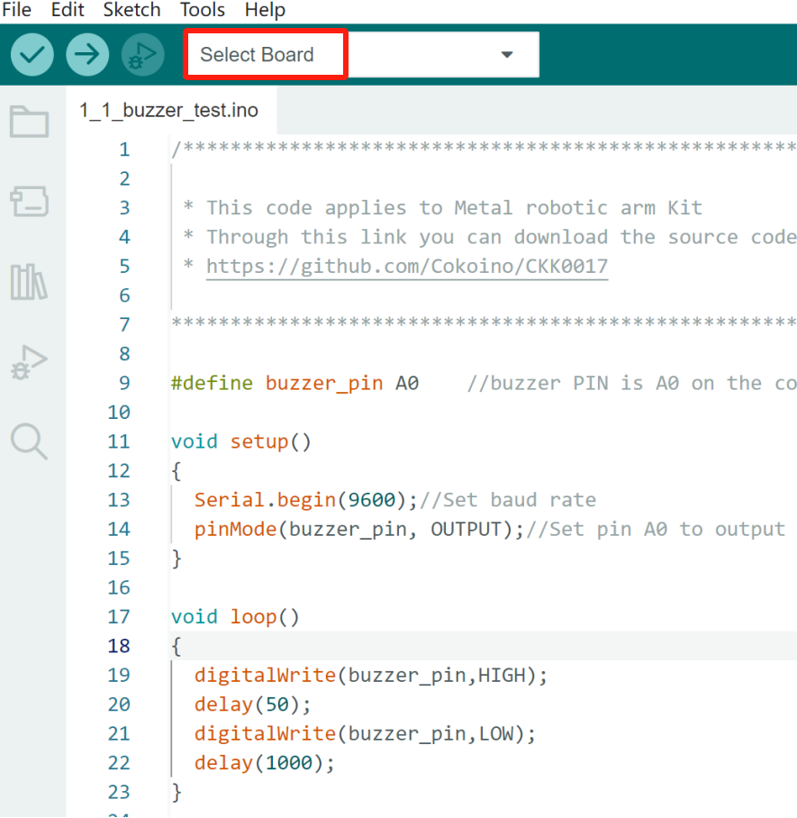

5.4 Select board

Click "Select Board", select the board as "Arduino UNO" in the pop-up "Select Other Board and Port" drop-down box,

Select PORTS as "COM13 Serial Port(USB)" (port is the port number of the board recognized by the computer, the port number recognized by each computer may be different, and the port recognized in this tutorial is COM13)

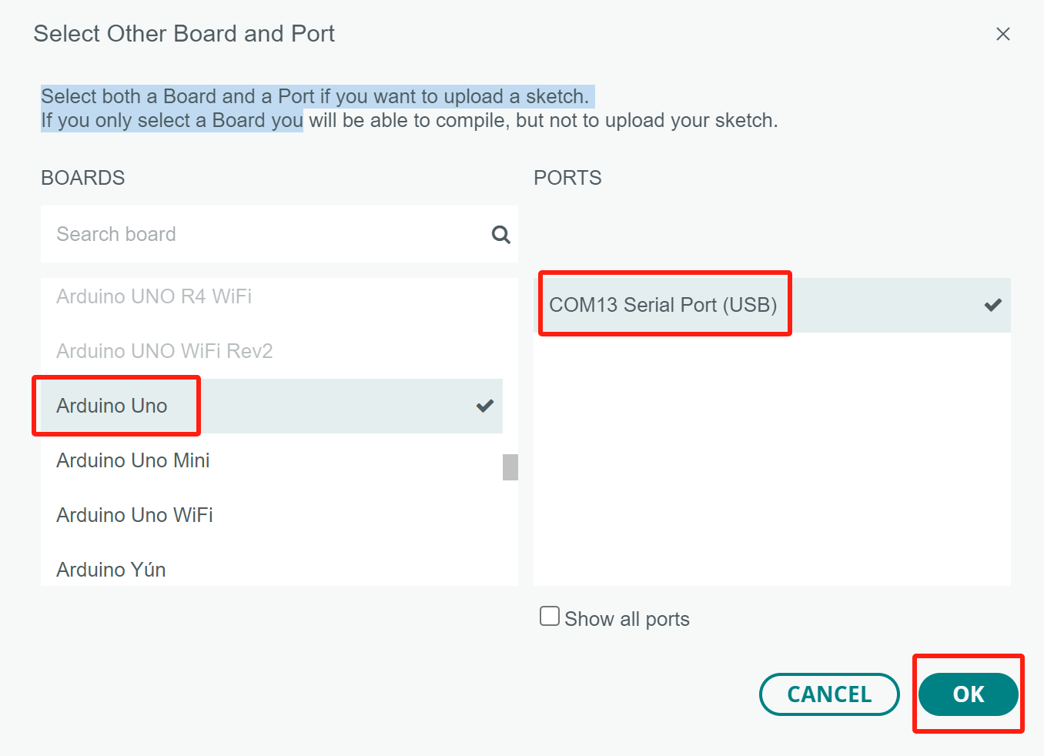

5.5 Compile

Click compile button，successfully compiled the code will display “Done compiling”

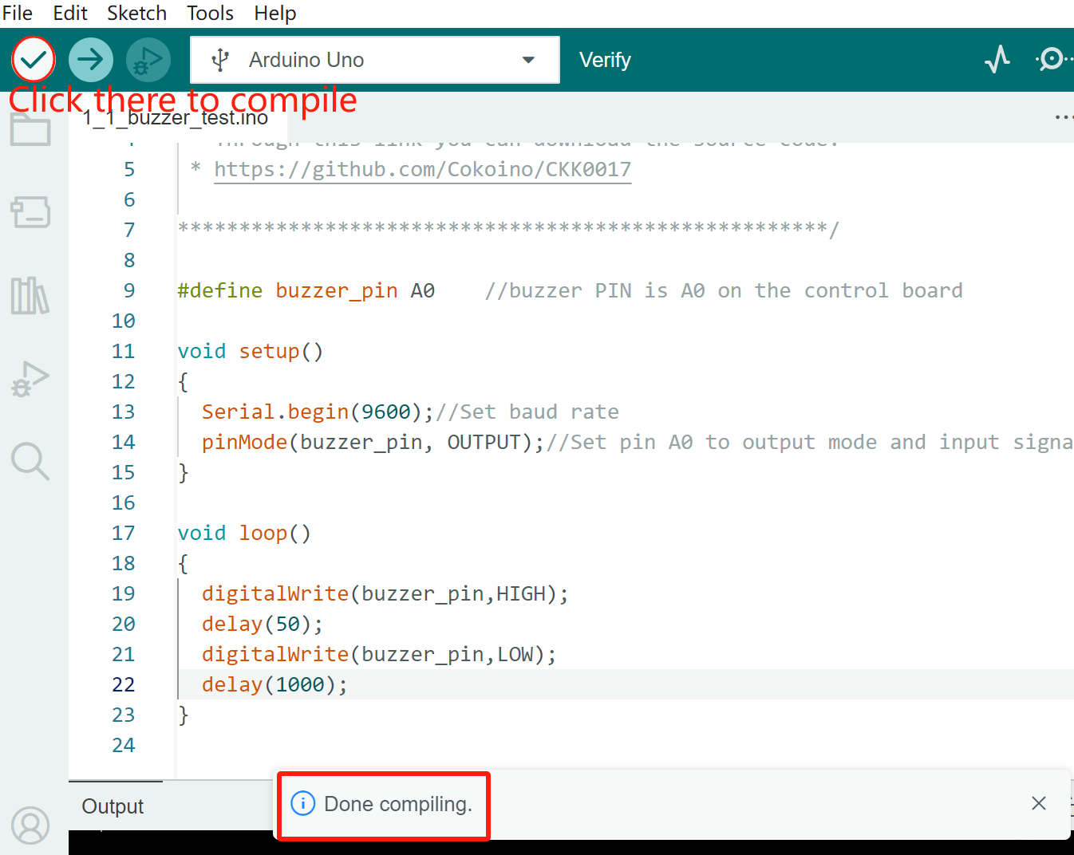

5.6 Upload

Click upload buttonto upload，successfully uploading the code will display “Done uploading”.After the code is uploaded successfully, the program starts to run automatically, and you can hear the “Di---Di--Di” sound from the buzzer on the Driver board.Unplug the USB cable and the buzzer will stop working.

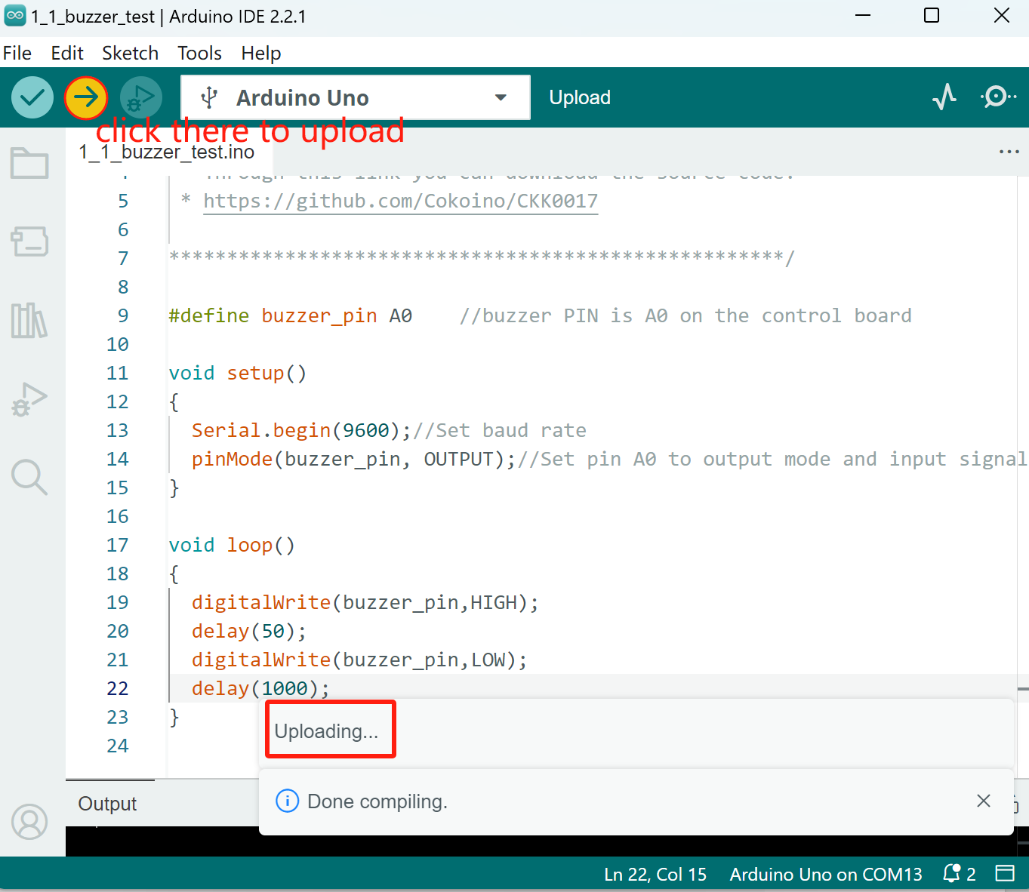

5.7 Code

1_1_buzzer_test.ino

#define buzzer_pin A0    //buzzer PIN is A0 on the control board

void setup()

{

  Serial.begin(9600);//Set baud rate

  pinMode(buzzer_pin, OUTPUT);//Set pin A0 to output mode and input signals to the buzzer

}

void loop()

{

  digitalWrite(buzzer_pin,HIGH);

  delay(50);

  digitalWrite(buzzer_pin,LOW);

  delay(1000);

}

# 6 Any questions and suggestions are welcome

Thank you for reading this document!

If you find any errors and omissions in the tutorial, or if you have any suggestions and questions, please feel free to contact us at:

**[cokoino@outlook.com](mailto:cokoino@outlook.com)**

We will do our best to make changes and publish revisions as soon as possible.

If you want to learn more about Arduino, Raspberry Pi, Smart Cars, Robotics and other interesting products in science and technology, please continue to visit our Amazon Store by search for "**LK COKOINO**" on Amazon. We will continue to launch fun, cost-effective, innovative and exciting products.

Thank you again for choosing Cokoino products.

**LK COKOINO**